Data Format from PUP_EN24C_T2R4_Manual.

2.4 Data Stream Sequences
The transmitter channel can be set as one channel or two channels. . The receiver channel can be set as one channel, two channels, and four channels. When only one transmitter is activated, the data stream sequences are illustrated in figure 7.

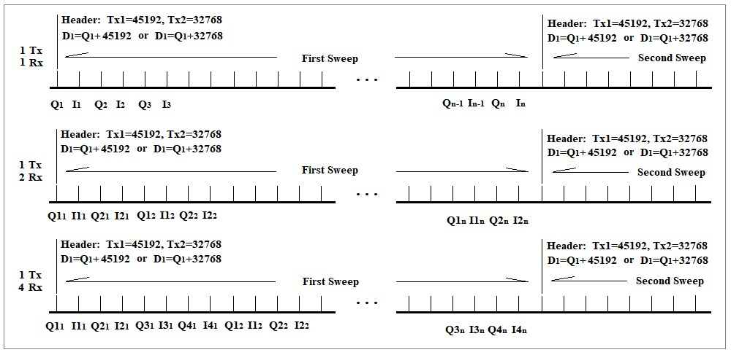
Figure 7. Single Transmitter data stream sequences
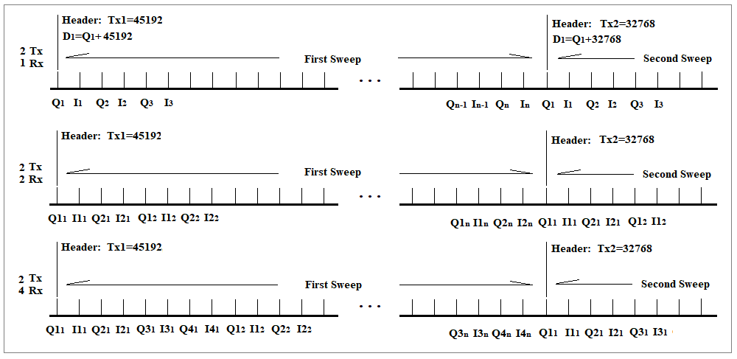
Figure 8. Two transmitter data stream sequences

When the device works in MIMO mode (Tx1.Tx2), both transmitters are alternately activated where only one is activated in each sweep. A header of 45192 (Tx1) or 32768 (Tx2) is always added to the first sample Q1 of each sweep. So when the value of the first sample is greater than 45192, then the data stream of this sweep comes from Tx1. When the value of the first sample is greater than 32768 and less than 45192, then the data stream of this sweep comes from Tx2. Subtracting 45192 or 32768 from the first sample value, the value of Q1 remains. Figure 8 are the two transmitter data stream sequences.
Direct data extraction steps:
- Calculate needed data length. (Matlab Gui source code: line2738).
- Get data (line2739): miniradargetdata(handles.EndPoint6_Num,DataLength).
- Discard first 2048 data that maybe the left over from last access.(line2742).
- When it is single channel Tx1, find header >49152. it is the first data location. (line2749).
When it is single channel Tx2, find header >32768. it is the first data location. (line 2835).
When working in dual channel, find both headers according (line 2922, line 2924).
- The data sequence following headers is in the format as show in figure 7 and 8 in the manual.

Saved data by using record function in the GUI:
Simply using load command in Matlab to get already formatted data and additional information.

